Ron Smith Update
July 2024
I’m living in Colorado Springs and have been since 1972 when I was released from the US Navy. I returned to Colorado after service in Vietnam and had a career in private practice clinical social work in Colorado Springs and consulting with a lot of schools and worked primarily with families.
I am recently remarried, and my wife and I have been traveling around the world. I’ve been able to do a lot of saltwater fly fishing in different places, including the Caribbean, the sea of Cortez and Slovenia. My son Craig is playing Saxophone on cruise ships as a featured performer and my older son Ryan is here in Colorado Springs as a technology specialist for a local school district and has three beautiful children.
Best wishes to all members of the class. Sorry I won’t be attending but I appreciate the association I’ve had with you all over the years. Have a good time and bless you all for what you’ve done to be successful people and contribute to the world.
Recent video of my outdoor activities go to:
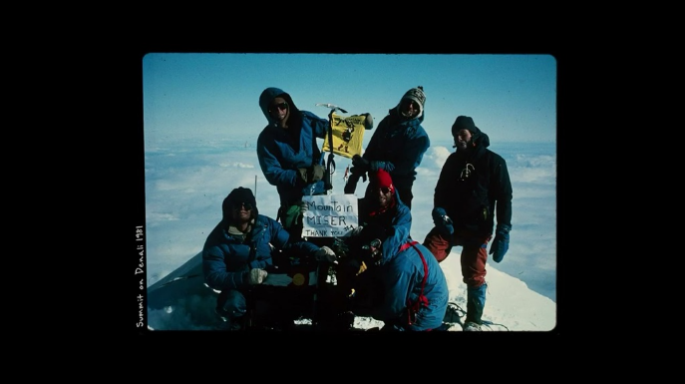
Buffalo Jackson Presents: Ron Smith
youtu.be

